Section 4.3.4 Validity Testing Results

Table 13. Comparison of empiric antibiotic assessment for UM HMS manually abstracted data (gold standard) to UM eCQM in 540 CAP patients.
* | UM HMS  Neither MRSA/ Pseudomonal (n=234) | UM HMS  Only MRSA (n=8) | UM HMS  Only Pseudomonal (n=54) | UM HMS  Both MRSA/ Pseudomonal (n=244)
UM eCQM Neither | 233 (99.6%) | 3 (37.5%) | 8 (14.8%) | 2 (0.8%)
UM eCQM  Only anti-MRSA | 1 (0.4%) | 5 (62.5%) | 0 | 0
UM eCQM  Only anti-Pseudomonal | 0 | 0 | 46 (85.2%) | 4 (1.6%)
UM eCQM  Both | 0 | 0 | 0 | 238 (97.5%)

Abbreviations: CAP, community-acquired pneumonia; UM, University of Michigan; HMS, Michigan Hospital Medicine Safety Consortium; MRSA, methicillin-resistant Staphylococcus aureus

Table 14. Sensitivity and Specificity of the eCQM in assessing inappropriate anti-MRSA or anti-Pseudomonal
n=540 patients | UM eCQM (electronic) n (%) | UM HMS data (chart review) n (%) | Sensitivity of UM eCQM (vs. UM HMS chart review) | Specificity of UM eCQM (vs. UM HMS chart review)
Have inappropriate anti-MRSA OR anti-Pseudomonal therapy | 294 (54.4%) | 286 (53.0%) | 95.8% (274/286) | 92.1% (234/254)
Abbreviations: CAP, community-acquired pneumonia; UM, University of Michigan; HMS, Michigan Hospital Medicine Safety Consortium; MRSA, methicillin-resistant Staphylococcus aureus

Table 15. Denominator exclusions to define the population: Hospitalized non-ICU adults with CAP; comparison of measured entities
Exclusion | Michigan  (n=49,205) | Utah  (n=5,909) | VA  (n=102,416)
Under 18 on admission | 8,905 (18.1%) | 0 | 0
Patient class NOT inpatient or observation | 4,289 (8.7%) | 908 (15.4%) | NA
Died in the first 48 hours of hospitalization | 709 (1.4%) | 133 (2.3%) | 418 (0.4%)
Any time in ICU in the first 48 hours of hospitalization | 10,910 (22.2%) | 2391 (40.5%) | 17512 (17.1%)
Admitted from another hospital or long-term acute care facility | 1,272 (2.6%) | 1,506 (25.5%) | 7153 (7.0%)
Concurrent infection by ICD10 | 7,903 (16.1%) | 2,424 (41.0%) | 24719 (24.1%)
Chest imaging required (day -3 to day 3 of admission) | 465 (0.9%) | 726 (12.3%) | 2189 (2.1%)
Ending population | 10,366 (21.1%) | 1049 (17.8%) | 60,943 (59.5%)

Table 16. Exclusions to Narrow Population to Uncomplicated CAP
Exclusion | Michigan (n=10,366) | Utah  (n=1049) | VA  (n=60,943)
Cystic Fibrosis | 286 (2.8%) | 19 (1.8%) | 18 (0.0%)
On mechanical ventilation in first 48 hours of hospitalization | 690 (6.7%) | 46 (4.4%) | NA
Absolute neutrophil count <500 cells/uL | 443 (4.3%) | 81 (7.7%) | 111 (0.2%)
Bronchiectasis | 791 (7.6%) | 58 (5.5%) | 2803 (4.6%)
HIV (irrespective of CD4) | 52 (0.5%) | 26 (2.5%) | 978 (1.6%)
Tracheostomy | 384 (3.7%) | 20 (1.9%) | 633 (1.0%)
Transplant in prior year | 1522 (14.7%) | 150 (14.3%) | 1478 (2.4%)
Hematologic malignancy | 1461 (14.1%) | 180 (17.2%) | 4762 (7.8%)
Pulmonary complication: | 263 (2.5%) | 38 (3.6%) | 1698 (2.8%)
Ending population | 6,285 (60.6%) | 655 (62.4%) | 49,774 (81.7%)

Table 17. Additional Exclusions Specific to Empiric Measure
Exclusion | Michigan (n=6,285) | Utah  (n=655) | VA  (n=51,760)
Risk factors for MRSA/Pseudomonas aeruginosa from prior cultures; culture data from year prior | * | * | *
Positive respiratory culture for Pseudomonas aeruginosa in prior year | 68 (1.1%) | 0 | 695 (1.3%)
Positive respiratory culture for MRSA in prior year | 39 (0.6%) | 0 | 294 (0.6%)
Patients with severe pneumonia (see definition below) | * | * | *
Severe pneumonia + prior hospitalization with IV antibiotic in prior 3 months | 677 (10.8%) | 36 (5.5%) | 2233 (4.3%)
Ending population | 5,553 (88.4%) | 619 (94.5%) | 48742 (94.2%)
*cell intentionally left empty

Table 18. Sensitivity/Specificity of Exclusion Criteria Comparing eCQM and Chart Review (UM, n=592)

* | UM eCQM data (electronic) n (%) | UM HMS data (chart review) n (%) | Sensitivity of UM eCQM (vs. UM HMS chart review) | Specificity of UM eCQM (vs. UM HMS chart review)
Empiric-specific Exclusions | n=592 | n=592 | n=592 | n=592
Positive respiratory culture for Pseudomonas aeruginosa in prior year | 10 (1.7%) | 8 (1.4%) | 75.0% (6/8) | 99.3% (580/584)
Positive respiratory culture for MRSA in prior year | 9 (1.5%) | 4 (0.7%) | 100.0% (4/4) | 99.2% (583/588)
Both severe pneumonia¹ AND prior hospitalization with IV antibiotic in prior 3 months | 43 (7.3%) | 30 (5.1%) | 60.0% (18/30) | 95.6% (537/562)
Prior admission with IV antibiotics (alone) | 101 (17.1%) | 114 (19.3%) | 70.2% (80/114) | 95.6% (457/478)
Severe pneumonia (alone) | 210 (35.5%) | 122 (20.6%) | 86.9% (106/122) | 77.9% (366/470)
*cell intentionally left empty
¹ Here, we compare the eCQM’s modified severity criteria (≥2 minor criteria on a single day in the first 48 hours of encounter) to the original ATS criteria which required 1 major or ≥3 minor criteria. The modified severity criteria are much more feasibility for the 3 hospitals the eCQM was tested within (see feasibility section for more details).

Figure 4. Relationship between excess antibiotic duration and inappropriately broad empiric antibiotic use.
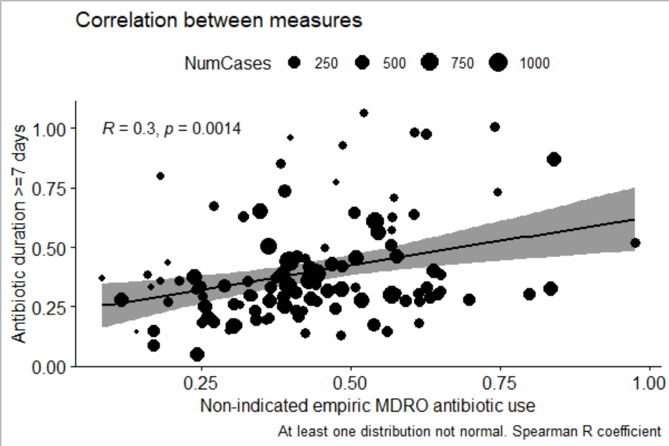
MDRO= Multi-Drug-Resistant Organisms
Patient data from 109 VA hospitals between January 1, 2022 and June 30, 2024. Each hospital is represented as a dot with larger hospitals having larger dots.

TEP Survey results:
Seven TEP members responded to the question, “How much do you agree with the following statement? The measure, as specified can be used to distinguish between better and worse performing hospitals,” with 1/7 (14.3%) reporting “Strongly agree”, 4/7 (57.1%) reporting “Agree”, and 2/7 (28.6%) reporting “Neutral.”
We also asked the TEP: “Are there any key data elements you believe are missed or not appropriately used in the determination as to whether therapy for MDRO is justified?” Of the 5 responses to this free text question, four responded “no”, with one adding “always concern of outside data not available at time of admission- but that can't be avoided”, supporting face validity of the measure. The fifth response was:

“I think pulling from the EHR is going to miss some people in whom MDRO therapy is justified because they have a history that is reported in text notes and is not retrievable in the EHR from prior medications and microbiology results. Diagnoses of bronchiectasis, severe COPD, other structural risk factors may also be missed if not coded during that hospitalization. We discussed the expectation that we don't think the measure should be 100%.” We agree that hospitals should not have 0% inappropriate broad spectrum antibiotic use as their goal to allow for incomplete data/appropriate variation.

Two TEP members responded to the free text question: “Please use the space below to provide any additional comments or suggestions related to the proposed measure.” The first response was: “There is no perfect measure here but I think simplifying the measure by taking out those who qualify for MDRO treatment would make it cleaner & more fair”. In the final measure, We excluded patients with risk factors for broad spectrum therapy from the denominator.
The second response was: “An unintended consequence of the 3 tiers could be that tier 2 could be perceived as also a bad thing and to avoid this tier, treatment could go from potentially justified undertreatment to use of anti-MRSA or anti-Pseudomonal to be in Tier 1”. The final measure was simplified by eliminating tiers.
Table 19. Outcomes for patients hospitalized with CAP receiving standard empiric CAP treatment vs inappropriate empiric broad-spectrum antibiotic treatment
Outcome | CAP Coverage (n=6071) | Inappropriate Empiric Broad-Spectrum Coverage (n=2215) | Unadjusted Odds Ratio  (95% CI) | Unadjusted P Values | Adjusted Odds Ratio  (95% CI) | Adjusted P Value
In-Hospital and 30-day Post-discharge mortality | 183 (3.0%) | 117 (5.3%) | 1.80 (1.42-2.29) | <.001 | 1.02 (0.82-1.30) | 0.85
30-day Post-discharge readmission | 626 (10.4%) | 344 (15.8%) | 1.63 (1.41-1.88) | <.001 | 1.18 (1.03-1.35) | 0.02
30-day Post-discharge ED visit | 548 (9.1%) | 236 (10.9%) | 1.24 (1.05-1.46) | 0.01 | 1.11 (0.95-1.29) | 0.18
In-Hospital and 30-day Post-discharge C. difficile infection | 15 (0.3%) | 12 (0.5%) | 2.20 (1.03-4.71) | 0.04 | 1.88 (0.85-4.16) | 0.12
In-Hospital and 30-day Post-discharge antibiotic-associated ADE | 139 (2.3%) | 71 (3.2%) | 1.46 (1.09-1.96) | 0.01 | 1.73 (1.24-2.43) | 0.001
Duration of Hospitalization, median (IQR) | 4 (3-6) | 5 (4-7) | 1.19 (1.16-1.21) | <.001 | 1.11 (1.09-1.13) | <.001
Transfer to ICU | 86 (1.4%) | 60 (2.7%) | 1.95 (1.39-2.75) | <.001 | 1.55 (1.10-2.19) | 0.01

Abbreviations: CAP, community-acquired pneumonia; ED, emergency department; ADE, adverse drug event; IQR, interquartile range; ICU, intensive care unit
Outcomes were adjusted for patient variables found to be significant (P<.05) and associated with treatment in the multivariate analysis as well as baseline characteristics know to be associated with each individual outcome.

