2.1. Logic Model
Our logic model is informed by Donabedian’s¹ classic structure-process-outcome model for the evaluation of quality in healthcare. Structure refers to the characteristics of the facility where care is delivered. The structure of care informs care processes, such as the delivery of palliative care services, and emotional and spiritual support to the Veteran and family member. These factors ultimately influence the overall rating of the quality of care received by the Veteran and family in the Veteran’s last month of life on the Bereaved Family Survey.

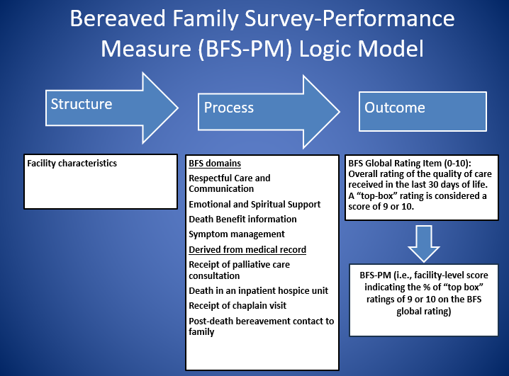
References
- Donabedian A: The quality of care. How can it be assessed?. Jama. 1988, 260 (12): 1743-1748. 10.1001/jama.260.12.1743.

