Supplemental Attachment (CBE ID 5608e)

3.1 Contributions Toward Closing Care Gaps
Evidence of Known Disparities: Glazer et al. (2021) examined Total UNC in 40 New York City hospitals and noted a differential rate for Black and Hispanic women that persisted after multivariable logistic regression analysis (adjusted odds ratio [aOR]: 1.5, 95% confidence interval [CI]: 1.3-1.9; aOR: 1.2, 95% CI: 1.1-1.4, respectively). However, they also noted that “Black and Hispanic women were more likely to deliver in hospitals with high complication rates than were white or Asian American women. Findings implicate hospital quality in contributing to preventable newborn health disparities among low-risk, term births.
In comparison, analysis performed by the California Maternal Quality Care Collaborative (CMQCC) of patients from 197 California hospitals using GEE Poisson regression modeling did not find a differential rate for Black and Hispanic women for Total UNC (adjusted risk ratio [RR]: 0.98, 95% CI: 0.88-1.09; aRR: 0.90, 95% CI: 0.85-0.95, respectively) (Supplementary Table 1). As in New York City, hospitals themselves appeared to be the important factor in driving the rate of UNC. This analysis is discussed in detail in the Methodology section below.
Methodology: CMQCC accessed stratum-specific severe and total UNC rates by maternal age at delivery, maternal race and ethnicity, payment for delivery, and urbanicity/rurality of the delivering hospitals. CMQCC performed GEE Poisson regression models with robust error estimates to calculate relative risk (RR) and 95% confidence interval (CI) for severe and total UNC across these social-contextual variables. The adjusted models included the following variables: maternal age at delivery, maternal pre-pregnancy BMI, maternal race/ethnicity, payment for delivery, prenatal care, nulliparous, infant birth weight > 4000 grams, gestation age, infant sex, induction of labor, mode of delivery, rural/urban location of the hospital and maternal comorbidities including chronic hypertension, preeclampsia, gestational diabetes, and diabetes.
This approach accounted for the clustering of outcomes within hospitals and provided robust estimates of disparities, adjusted for relevant clinical risk factors and maternal demographics.
Results/Interpretation: Analyses performed by CMQCC are shown in Supplementary Table 1 and indicate that any modest observed differences in patient-level UNC for race/ethnicity and age are not significant when risk-adjusted for the other factors listed above.
CMQCC further categorized hospital performance as follows: “Within expected range” (<=Q3); “Alert” (from Q3 to Q3 + 1.5 IQR), and “Outlier” (above Q3+1.5 IQR) and their analysis demonstrated that adjusting for individual risk factors, including age and payment, resulted in minimal changes in hospital rates and no change in performance groups. CMQCC also examined hospitals with the highest number of Black patients and compared the proportion that fell into “Alert” and “Outlier” categories to all other hospitals. Among the 25 hospitals with the highest number of Black infants meeting UNC inclusion criteria, 1 fell into the “Outlier” category (4.0%) and 3 fell into the “Alert” category (12.0%), comparable to overall rates of 6.2% (Outliers) and 14.5% (Alert). These findings suggest that there is not a need for risk adjustment for race, and the focus should be on hospital QI for all parturients and infants.
Turning to the effect of Medicaid births on UNC rates, CMQCC examined the rates of Total and Severe UNC in hospitals with the highest numbers of Medicaid births. Among the highest 10 facilities, none had Total UNC rate or Severe UNC in the Alert or Outlier categories. In the top 40 facilities for Medicaid births, for Total UNC, 10% were in the Alert and 10% in the outlier categories; for Severe UNC, there were none in the Alert category and 5% in the Outlier category. These rates are similar to the rates seen in the population as a whole: Total UNC-16% in Alert and 8% in Outlier; Severe UNC-14% in Alert and 8% in Outlier. These data suggest that a high number of Medicaid births does not in itself disadvantage a hospital for either Total or Severe UNC.
See Section 5.4.1 for a discussion of risk adjustment. Importantly, infants more at risk for experiencing adverse outcomes (premature babies, low birth weight infants, infants with congenital malformations, exposure to maternal substance use and other pre-existing conditions) were excluded from the target population. Thus, many factors that could drive the need for risk adjustment were excluded a priori.
Anticipated Impact: In California, CMQCC provides all participating hospitals with the opportunity to examine all measures by race and ethnicity as part of their QI process. Should a disparity arise, the cases can be examined to address general and specific issues. This is in concordance with the Glazer et al. (2021) article noted above. Their conclusion included the following statement: “Quality improvement targeting routine obstetric and neonatal care is critical for equity in perinatal outcomes.” This measure is the only current measure that targets the care of newborns without preconditions that account for 85% of the neonatal population.
Reference List:
Glazer, K. B., Zeitlin, J., Egorova, N. N., Janevic, T., Balbierz, A., Hebert, P. L., & Howell, E. A. (2021). Hospital quality of care and racial and ethnic disparities in unexpected newborn complications. Pediatrics, 148(3), e2020024091. https://doi.org/10.1542/peds.2020-024091

California Maternal Quality Care Collaborative (CMQCC). (2025). Unexpected Complications in Term Infants (CBE #0716). Partnership for Quality Measurement. https://p4qm.org/measures/0716
Supplementary Table 1. UNC Rate (%) among 301,114 newborns from 197 California Hospitals in 2022, by maternal social demographic characteristics and hospital-level factors (Section 3.1).
 | N of UNC Denominator | Severe UNC |  |  |  | Total UNC
Characteristics | N of UNC Denominator | N | Rate (%) | Crude RR  (95% CI) | Adj RR*  (95% CI) | N | Rate (%) | Crude RR  (95% CI) | Adj RR*  (95% CI)
Maternal age at delivery
< 35 | 222,259 | 2,767 | 1.24 | Ref | Ref | 6,150 | 2.77 | Ref | Ref
>= 35 | 78,855 | 835 | 1.06 | 0.85 (0.79, 0.92) | 1.00 (0.92, 1.09) | 1,974 | 2.50 | 0.90 (0.86, 0.95) | 1.01 (0.95, 1.07)
Maternal race/ethnicity
White | 81,075 | 983 | 1.21 | Ref | Ref | 2,315 | 2.86 | Ref | Ref
Black | 14,594 | 230 | 1.58 | 1.30 (1.13, 1.50) | 1.13 (0.97, 1.32) | 457 | 3.13 | 1.10 (0.99, 1.21) | 0.98 (0.88, 1.09)
Asian | 43,611 | 423 | 0.97 | 0.80 (0.71, 0.90) | 0.93 (0.82, 1.05) | 1,029 | 2.36 | 0.83 (0.77, 0.89) | 0.94 (0.87, 1.02)
Hispanics | 147,977 | 1,763 | 1.19 | 0.98 (0.91, 1.06) | 0.93 (0.85, 1.01) | 3,874 | 2.62 | 0.92 (0.87, 0.97) | 0.90 (0.85, 0.95)
Others | 3,142 | 48 | 1.53 | 1.26 (0.94, 1.68) | 1.07 (0.79, 1.46) | 107 | 3.41 | 1.19 (0.98, 1.45) | 1.06 (0.86, 1.30)
Missing | 10,715
Payment for delivery
Non-Medi-Cal | 171,169 | 1,895 | 1.11 | Ref | Ref | 4,422 | 2.58 | Ref | Ref
Medi-Cal | 129,939 | 1,707 | 1.31 | 1.19 (1.11, 1.27) | 1.22 (1.12, 1.33) | 3,702 | 2.85 | 1.10 (1.06, 1.15) | 1.14 (1.08, 1.21)
Missing | 6
Geographic location of hospitals
Non-Rural | 292,359 | 3,405 | 1.16 | Ref | Ref | 7,827 | 2.68 | Ref | Ref
Rural | 8,755 | 197 | 2.25 | 1.93 (1.67, 2.23) | 1.94 (1.46, 2.59) | 297 | 3.39 | 1.27 (1.13, 1.42) | 1.30 (1.04, 1.63)
*Adjusted relative risks (RR) and 95% confidence intervals (CI) derived from multivariable GEE Poisson regression model with the following covariates: maternal age at delivery, maternal pre-pregnancy BMI, maternal race/ethnicity, payment for delivery, prenatal care, nulliparous, infant birth weight > 4000 grams, gestation age, infant sex, induction of labor, mode of delivery, rural/urban location of the hospital and maternal comorbidities including chronic hypertension, preeclampsia, gestational diabetes, and diabetes.
California Maternal Quality Care Collaborative (CMQCC). (2025). Unexpected Complications in Term Infants (CBE #0716). Partnership for Quality Measurement. https://p4qm.org/measures/0716
5.1 Data and Samples
Supplementary Table 2: Characteristics of Measured Entities (Section 5.1.3)
Characteristic | Category | N | Percent
Hospital Type | Acute Care - Department of Defense | 19 | 6.6%
Hospital Type | Acute Care Hospitals | 255 | 88.5%
Hospital Type | Critical Access Hospitals | 8 | 2.8%
Hospital Type | Missing | 6 | 2.1%
Urbanicity | Rural | 51 | 17.7%
Urbanicity | Urban | 230 | 79.9%
Urbanicity | Missing | 7 | 2.4%
Region | Midwest | 71 | 24.7%
Region | Northeast | 32 | 11.1%
Region | South | 123 | 42.7%
Region | West | 56 | 19.4%
Region | Missing | 6 | 2.1%
Bed Count | 6-24 beds | 7 | 2.4%
Bed Count | 25-49 beds | 19 | 6.6%
Bed Count | 50-99 beds | 35 | 12.2%
Bed Count | 100-199 beds | 63 | 21.9%
Bed Count | 200-299 beds | 45 | 15.6%
Bed Count | 300-399 beds | 35 | 12.2%
Bed Count | 400-499 beds | 18 | 6.2%
Bed Count | 500 or more beds | 41 | 14.2%
Bed Count | Missing | 25 | 8.7%
Note: Missing values reflect hospital characteristics that were not available through publicly accessible data sources

Supplementary Table 3: Characteristics of Units of the Eligible Population (Section 5.1.4)
Characteristic | Category | N | Percent
Ethnicity | Hispanic or Latino | 75,697 | 21.8%
Ethnicity | Not Hispanic or Latino | 228,622 | 65.7%
Ethnicity | Missing | 43,596 | 12.5%
Race | American Indian or Alaska Native | 2,148 | 0.6%
Race | Asian | 15,353 | 4.4%
Race | Black or African American | 45,594 | 13.1%
Race | Native Hawaiian or Other Pacific Islander | 2,053 | 0.6%
Race | Other Race | 49,843 | 14.3%
Race | White | 184,038 | 52.9%
Race | Missing | 48,886 | 14.1%
Sex | Female | 164,180 | 47.2%
Sex | Male | 163,629 | 47%
Sex | Missing | 20,106 | 5.8%

Note: Missing values indicate patient demographic characteristics that were not available in the patient￼level data
5.4 Risk Adjustment
The following figures (Supplementary Figures 1-12) were obtained from analyses conducted by CMQCC to assess whether risk adjustment was necessary for the chart-abstracted version of the PC-06 measure.
Reference:
California Maternal Quality Care Collaborative (CMQCC). (2025). Unexpected Complications in Term Infants (CBE #0716). Partnership for Quality Measurement. https://p4qm.org/measures/0716

Supplementary Figure 1: Histogram of severe UNC rate among 197 California hospitals in 2022. (Section 5.4.1b)
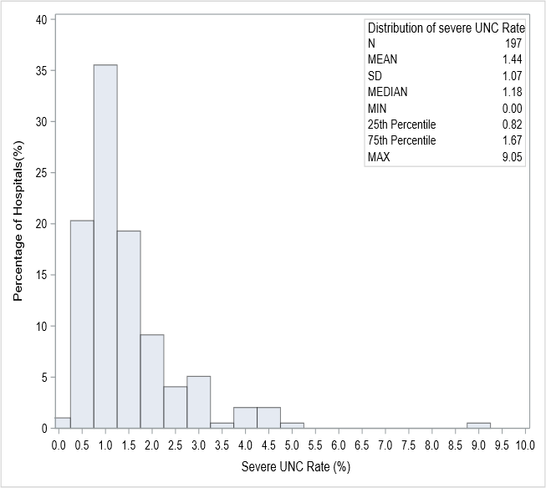

Supplementary Figure 2. Observed and risk-adjusted severe UNC rate among 197 California hospitals in 2022. (Section 5.4.1b)
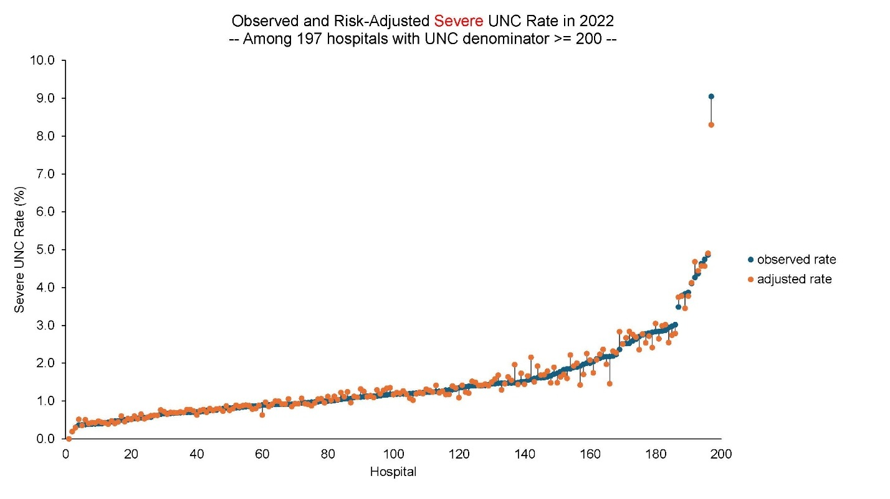
Supplementary Figure 3. Histogram of total UNC rate among 197 California hospitals in 2022. (Section 5.4.1b)
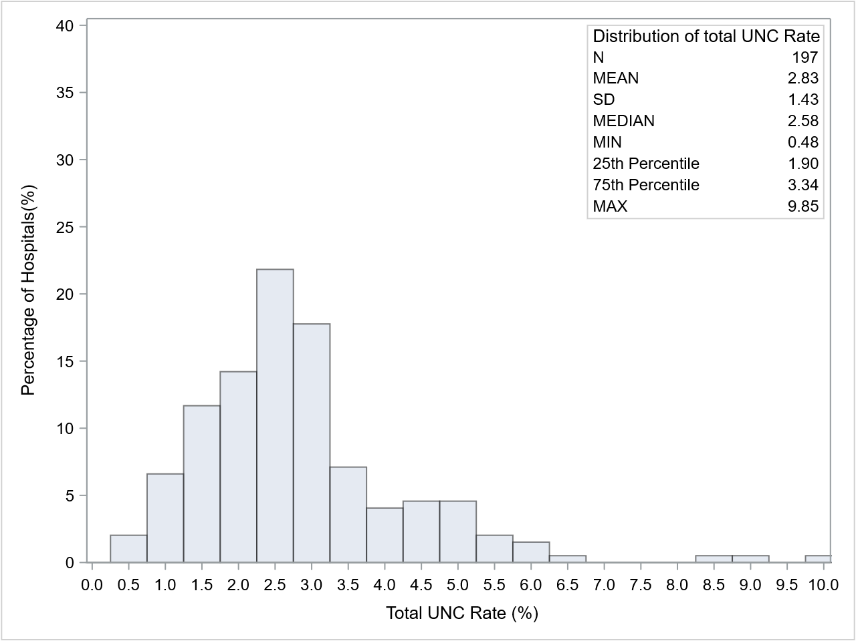
Supplementary Figure 4. Observed and risk-adjusted total UNC rate among 197 California hospitals in 2022. (Section 5.4.1b)
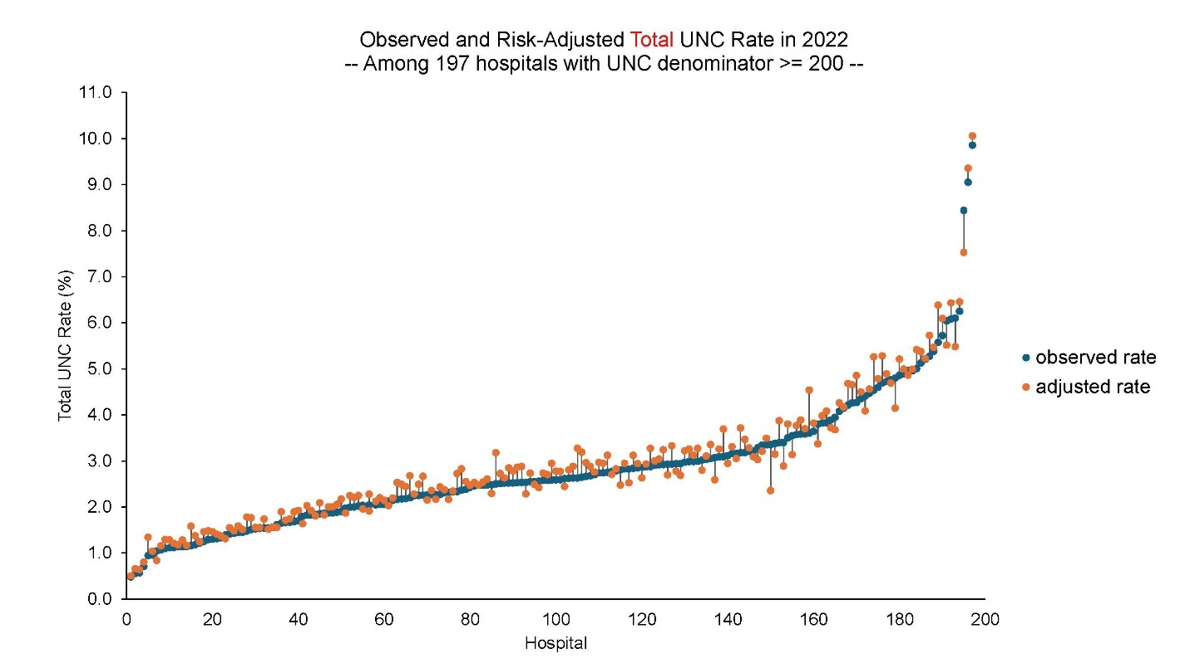
Supplementary Figure 5. Histogram of severe UNC rate among a) 43 AAP Level I, and b) 154 AAP Level II-IV California hospitals in 2022. (Section 5.4.1b)
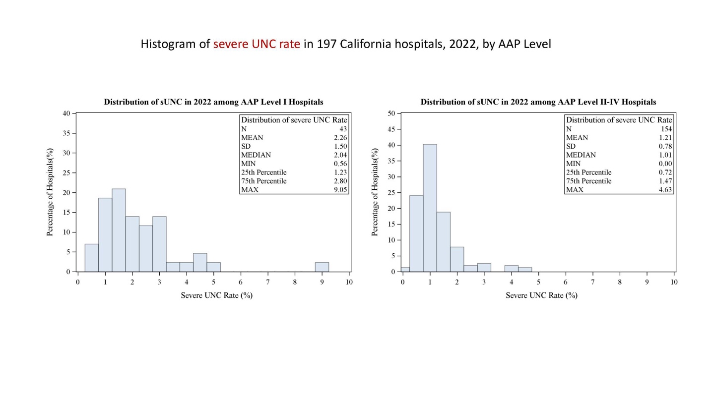
Supplementary Figure 6. Observed and risk-adjusted severe UNC rate among 43 AAP Level I California hospitals in 2022. (Section 5.4.1b)
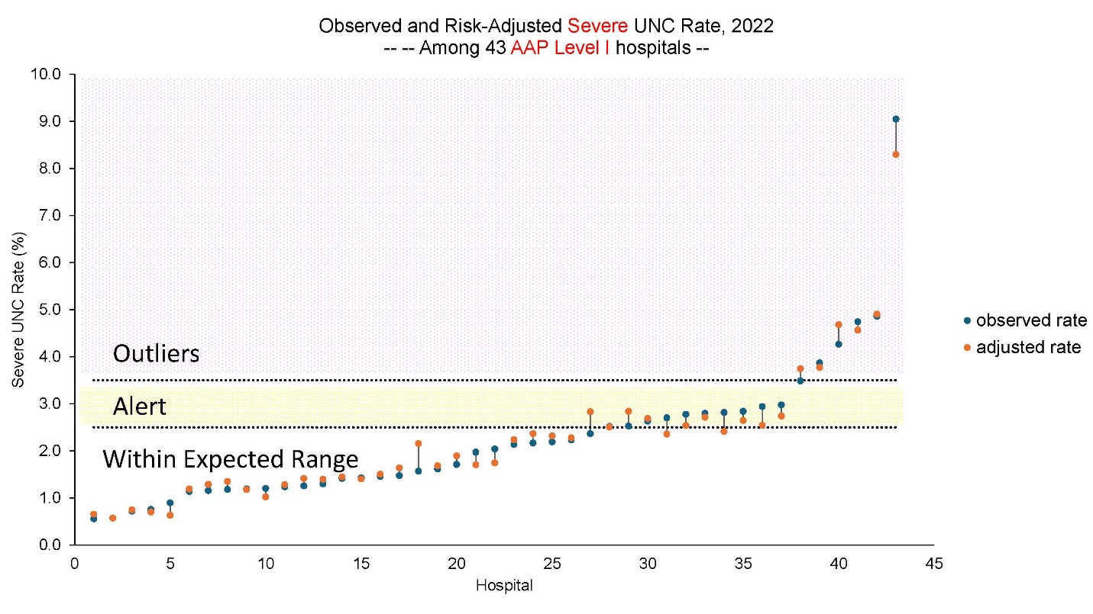

Supplementary Figure 7. Observed and risk-adjusted severe UNC rate among 154 AAP Level II-IV California hospitals in 2022. (Section 5.4.1b)
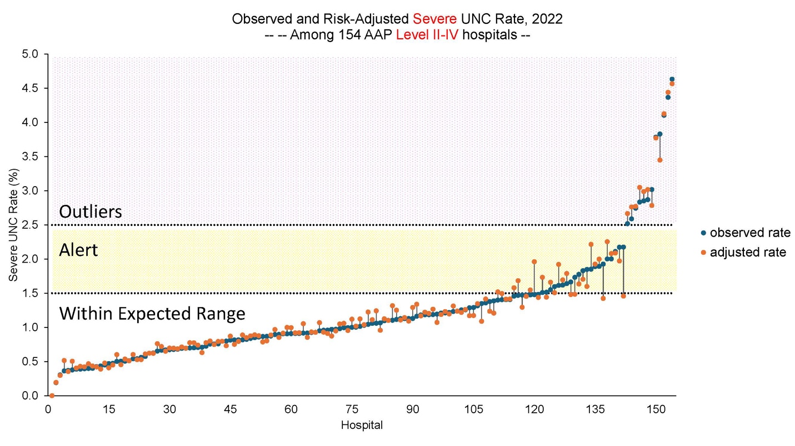

Supplementary Figure 8. Histogram of total UNC rate among a) 43 AAP Level I, and b) 154 AAP Level II-IV California hospitals in 2022. (Section 5.4.1b)
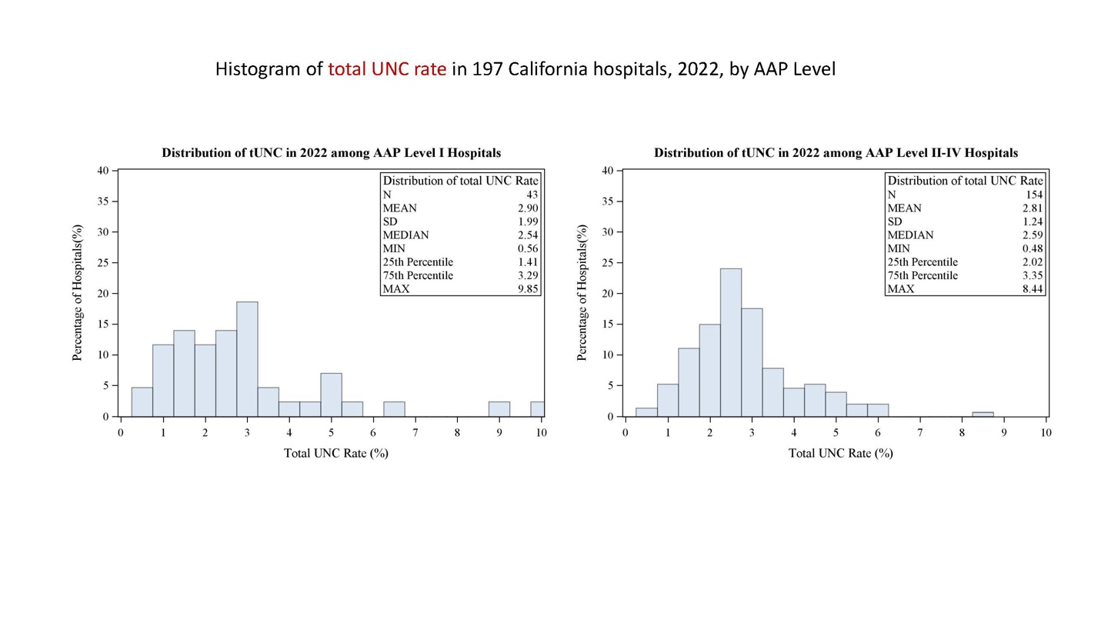
Supplementary Figure 9. Observed and risk-adjusted total UNC rate among 43 AAP Level I California hospitals in 2022. (Section 5.4.1b)
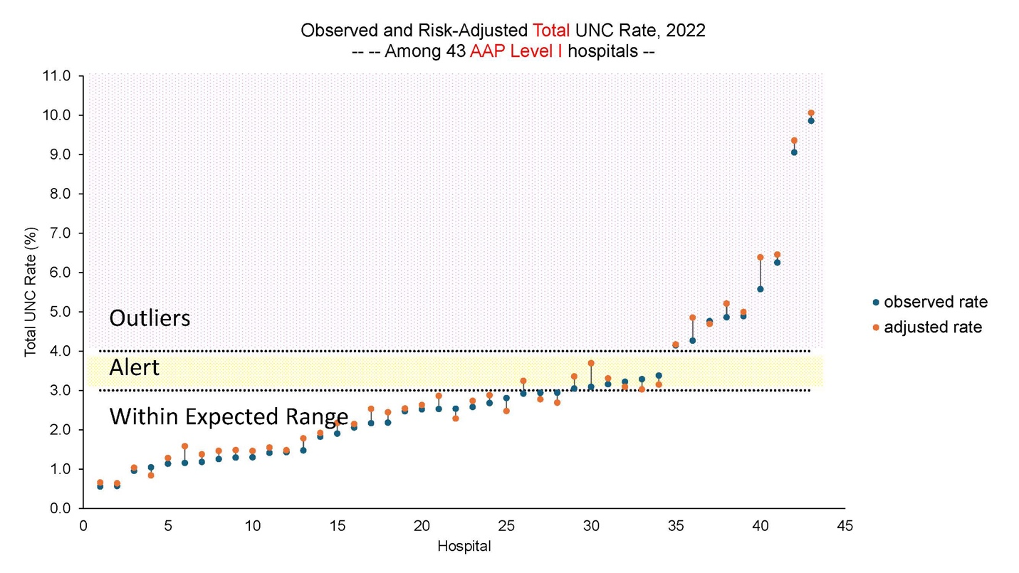
Supplementary Figure 10. Observed and risk-adjusted total UNC rate among 154 AAP Level II-IV California hospitals in 2022. (Section 5.4.1b)
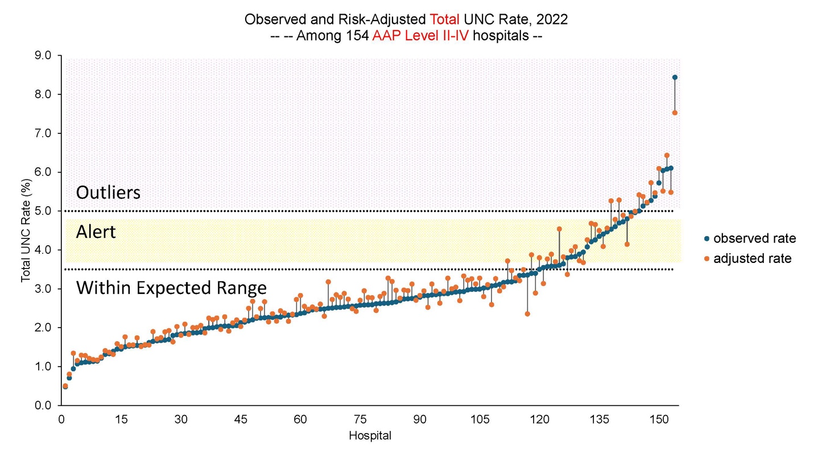

Supplementary Figure 11. Observed and risk-adjusted severe UNC rate among 53 AAP Level I California hospitals in 2011-2022. (Section 5.4.1b)
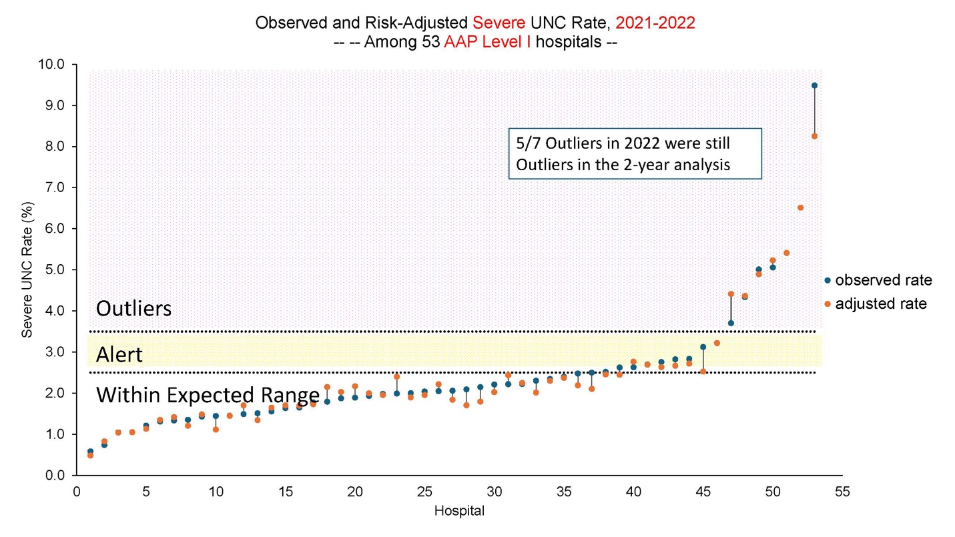

Supplementary Figure 12. Observed and risk-adjusted total UNC rate among 53 AAP Level I California hospitals in 2011-2022. (Section 5.4.1b)
