Validity Testing (CBE 5608e)
ePC-06 Data-element validity assessment
Data-element validity was evaluated by comparing EHR data to re-abstracted data serving as gold standard. High agreement indicates that electronic extraction accurately represents the underlying clinical record.
The data element validity was assessed based on the sample from two hospital systems (N=32 and 29, respectively) as follows:
- All clinical data elements and all editable demographic elements were scored.
- All measure data are re-abstracted with original electronic data extraction having been blinded so that the re-abstraction was not biased.
- Re-abstracted data are compared with original electronic data for each data element and at the overall measure result level. Data element and measure agreement rates were calculated. Clinical and demographic data were scored separately. The measure agreement rate was corrected for chance variation with the Cohen’s kappa statistic.
- Sensitivity, specificity, positive predictive value, and negative predictive value are provided separately for each measure result (e.g., numerator, denominator).
Measure Result Agreement Rate:
System | N | Agreement Rate | Cohen’s kappa
A | 32 | 96.9% | 0.95
B | 29 | 100.0% | 1.00
Total | 61 | 98.4% | 0.97

Sensitivity, specificity, positive predictive value (PPV), negative predictive value (NPV) by measure result:
Measure Result | N | Sensitivity | Specificity | PPV | NPV
Not in Initial Patient Population | 2 | 1.00 | 1.00 | 1.00 | 1.00
Denominator Exclusion | 9 | 1.00 | 0.98 | 0.90 | 1.00
Denominator | 23 | 0.96 | 1.00 | 1.00 | 0.97
Numerator | 26 | 1.00 | 1.00 | 1.00 | 1.00

Example interpretations:
- Sensitivity: among re-abstracted Numerator cases, what proportion did the electronic extraction correctly identify as a Numerator case?
- Specificity: among re-abstracted non-Numerator cases (i.e., Denominator, Denominator Exclusion, or Not in Initial Population), what proportion did the electronic extraction correctly identify as a non-Numerator case?
- PPV: among electronically extracted Numerator cases, what proportion were Numerator cases based on the re-abstraction?
- NPV: among electronically extracted non-Numerator cases, what proportion were non-Numerator cases based on the re-abstraction?

Data Element Agreement Rate:
Clinical Data Elements | System A  Match Rate | System A  N | System A  Match | System B  Match Rate | System B  N | System B  Match | Total  Match Rate | Total  N
Admission Date/Time  (Relevant Period Start Time) | 100.0% | 32 | 32 | 100.0% | 29 | 29 | 100.0% | 61
Author Date Time | 98.4% | 64 | 63 | 51.7% | 58 | 30 | 76.2% | 122
Birth Weight EMR display | 100.0% | 32 | 32 | 100.0% | 29 | 29 | 100.0% | 61
Diagnosis EMR display | 63.7% | 91 | 58 | 100.0% | 140 | 140 | 85.7% | 231
Diagnosis EMR display  (Single Live Term Newborn) | 100.0% | 32 | 32 | 100.0% | 377 | 377 | 100.0% | 409
Discharge Date/Time  (Relevant Period End Time) | 100.0% | 32 | 32 | 100.0% | 29 | 29 | 100.0% | 61
Discharge Disposition EMR display | 96.9% | 32 | 31 | 100.0% | 29 | 29 | 98.4% | 61
DOB | 100.0% | 32 | 32 | 100.0% | 29 | 29 | 100.0% | 61
Encounter Inpatient EMR display | 100.0% | 32 | 32 | 100.0% | 29 | 29 | 100.0% | 61
Gestational age--at birth EMR display | 100.0% | 32 | 32 | 100.0% | 29 | 29 | 100.0% | 61
Medical Record Number | 100.0% | 32 | 32 | 100.0% | 29 | 29 | 100.0% | 61
Organizational OID | 100.0% | 32 | 32 | 100.0% | 29 | 29 | 100.0% | 61
Procedure Start Date Time | 39.4% | 33 | 13 | 85.0% | 20 | 17 | 56.6% | 53
Procedure EMR display | 39.4% | 33 | 13 | 100.0% | 20 | 20 | 62.3% | 53
Demographic  Data Elements | System A  Match Rate | System A  N | System A  Match | System B  Match Rate | System B  N | System B  Match | Total  Match Rate | Total  N
Race Code | 100.0% | 32 | 32 | 89.7% | 29 | 26 | 95.1% | 61
Ethnicity Code | 68.8% | 32 | 22 | 93.1% | 29 | 27 | 80.3% | 61
Payer Code | 100.0% | 32 | 32 | 100.0% | 29 | 29 | 100.0% | 61
ONC Administrative Sex Code | 100.0% | 32 | 32 | 100.0% | 29 | 29 | 100.0% | 61

Convergent validity
Spearman correlations between ePC-06 and ePC-02 measures
PC-06 measure rate | Comparator measure | Spearman Rho | N | P-value
Overall rate (PC-06.0) | PC-02 (Cesarean birth) | -0.105 | 283 | 0.078
Severe rate (PC-06.1) | PC-02 (Cesarean birth) | -0.196 | 283 | < 0.001
Moderate rate (PC-06.2) | PC-02 (Cesarean birth) | 0.026 | 283 | 0.664

Distribution of Length of Stay (LOS) for newborns with and without complications
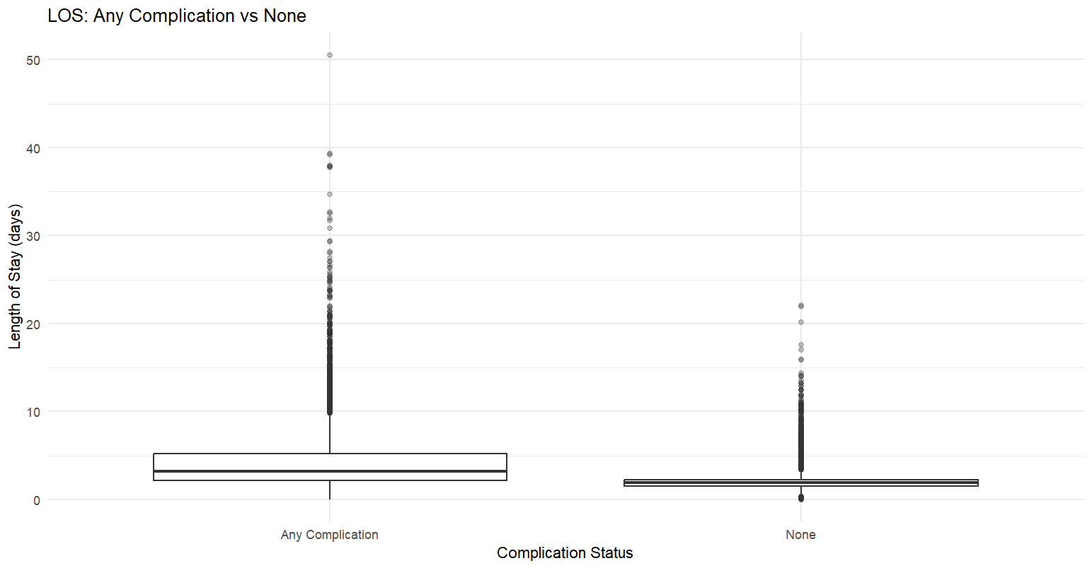
Distribution of LOS for newborns with complications by NICU status
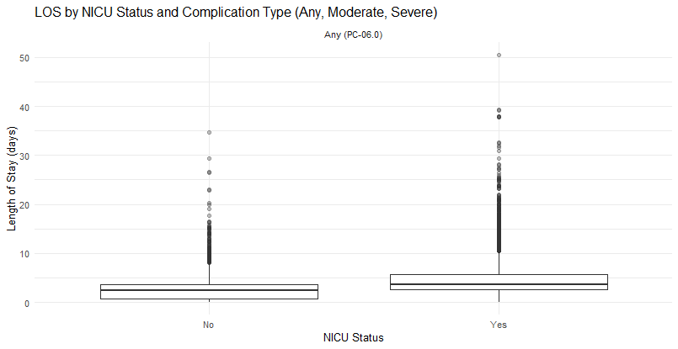
T-test (two-sided) for the difference in means by LOS for newborns with and without complications
Absolute Difference (days) | Mean LOS (days) for newborns without complications | Mean LOS (days) for newborns with any complications (ePC-06.0) | t-statistic | p-value
2.1 | 1.9 | 4.1 | -70.7 | <0.001

T-test (two-sided) for the difference in means by LOS for newborns with and without complications by NICU status
Absolute Difference (days) | Mean LOS (days) for newborns with complications in the non-NICU hospitals | Mean LOS (days) for newborns with complications in the NICU hospitals | t-statistic | p-value
1.8 | 2.7 | 4.5 | -30.8 | <0.001

